L0 Final Assessment
OOPs Coding / Practical

Employee Name: Nisanth Saravanan
Employee ID: 12576

Question:

Case Study: Personal Task Manager

This C# program simulates a simple to-do list application, demonstrating core object-oriented programming (OOP) principles. The application utilizes a Task struct to represent individual tasks, each containing a description and completion status. An abstract class, TaskPersistence, defines the contract for saving and loading tasks, enabling flexibility in data storage mechanisms. FileTaskPersistence, a concrete implementation, handles file-based persistence. The TodoList class encapsulates the logic for managing a list of tasks, using a vector to store them and employing dependency injection to accept a TaskPersistence object. This allows the TodoList to work with different persistence strategies.

The program features a menu-driven interface,
1. Add Task
2. Display Tasks
3. Mark Task Complete
4. Save Tasks
5. Load Tasks
6. Exit

The code demonstrates abstraction, inheritance, encapsulation, and polymorphism, showcasing a well-structured OOP approach to a basic to-do list application.

Code:

Task.cs

struct Task
{
public int ID;
public string Description;
public bool Status;

public Task(int id, string description)
{
this.ID = id;
this.Description = description;
this.Status = false;
}
};

Update.cs

//A CONCRETE CLASS DECLARED AND DEFINED WITH THE SOLE PURPOSE OF MARKING TASKS'S STATUS AS TRUE i.e COMPLETED.
class Update
{
public void MarkAsComplete(List<Task> myTasks)
{
Console.Write("\nENTER THE ID OF THE TASK TO MARK AS COMPLETED: ");
int id = int.Parse(Console.ReadLine());

//CHECKING IF SUCH A TASK IS PRESENT
bool found = false;
foreach (Task task in myTasks)
{
if (task.ID == id)
{
found = true;
break;
}
}

//IF FOUND:
if (found)
{
Task TaskToComplete = myTasks.Find(task => task.ID == id); //FINDING THE TASK AND PLACING IT IN A TASK VARIABLE.
myTasks.Remove(TaskToComplete); //DELETES THE SAID TASK, THUS REMOVING IT FROM CURRENT INDEX.
TaskToComplete.Status = true; //UPDATING STATUS TO TRUE i.e COMPLETED.
myTasks.Add(TaskToComplete); //RE-ADDING THE TASK TO THE END OF THE LIST.
Console.WriteLine("THE SAID TASK HAS BEEN MARKED AS COMPLETE!");
}
//IF NOT FOUND:
else
{
Console.WriteLine("THE SAID TASK IS NOWHERE TO BE FOUND!");
}
}
}

TaskPersistence.cs

//A SIMPLE ABSTRACT CLASS THAT DEFINES CONTRACT FOR VARIOUS OPERATIONS SUCH AS ADDING, DISPLAYING, REMOVING AND SEARCHING.
abstract class TaskPersistence()
{
public abstract void AddTasks(List<Task> myTasks); //SHOWCASING METHOD OVERRIDING.
public abstract void DisplayTasks(List<Task> myTasks); //SHOWCASING METHOD OVERLOADING.
public abstract void DisplayTasks(List<Task> myTasks, bool status); //SHOWCASING METHOD OVERLOADING.
public abstract void RemoveTasks(List<Task> myTasks); //SHOWCASING METHOD OVERRIDING.
public abstract void SearchTasks(List<Task> myTasks); //SHOWCASING METHOD OVERRIDING.
}

FileTaskPersistence.cs

//A CONCRETE CLASS THAT IMPLEMENTS AN ABSTRACT CLASS, AND PROVIDES DEFINITION TO THE FUNCTIONS DELARED WITHIN THE ABSTRACT CLASS.
class FileTaskPersistence : TaskPersistence
{
//SHOWCASING METHOD OVERRIDING.
public override void AddTasks(List<Task> myTasks)
{
Console.Write("\nENTER THE ID OF THE TASK: ");
int ID = int.Parse(Console.ReadLine());
Console.Write("ENTER THE TASK DESCRIPTION:");
string description = Console.ReadLine();

//ADDING THE TASK TO THE LIST USING THE .ADD() AND A STRUCT CONSTRUCTOR.
myTasks.Add(new Task(ID, description));
Console.WriteLine($"THE NEW TASK OF ID: {ID}, HAS BEEN ADDED!");
}

//SHOWCASING METHOD OVERRIDING.
public override void DisplayTasks(List<Task> myTasks)
{
Console.WriteLine("\n=========================");
Console.WriteLine("ALL TASKS:");
Console.WriteLine("=========================");
foreach (Task task in myTasks)
{
Console.WriteLine($"\n{task.ID}: {task.Description}, Completed?: {task.Status}");
}
}

//SHOWCASING METHOD OVERLOADING.
public override void DisplayTasks(List<Task> myTasks, bool status)
{
Console.WriteLine("\n=========================");
Console.WriteLine("INCOMPLETE TASKS:");
Console.WriteLine("=========================");
foreach (Task task in myTasks)
{
if (task.Status == status)
{
Console.WriteLine($"\n{task.ID}: {task.Description}"); //PRINTS ONLY IS THE STATUS IS SET TO FALSE.
}
}
}

//SHOWCASING METHOD OVERRIDING.
public override void RemoveTasks(List<Task> myTasks)
{
Console.Write("\nENTER THE ID OF THE TASK TO REMOVE: ");
int id = int.Parse(Console.ReadLine());

//CHECKING IF SUCH A TASK IS PRESENT.
bool found = false;
foreach (Task task in myTasks)
{
if (task.ID == id)
{
found = true;
break;
}
}

//IF FOUND:
if (found)
{
Task TaskToRemove = myTasks.Find(task => task.ID == id); //FINDING THE TASK AND PLACING IT IN A TASK VARIABLE.
myTasks.Remove(TaskToRemove); //USING .REMOVE() TO DELETE THE SAID TASK FROM ITS INDEX INT THE ARRAY.
Console.Write("THE SAID TASK HAS BEEN REMOVED SUCCESSFULLY!");
}
//IF NOT FOUND:
else
{
Console.Write("THE SAID TASK IS NOWHERE TO BE FOUND!");
}
}

//SHOWCASING METHOD OVERRIDING.
public override void SearchTasks(List<Task> myTasks)
{
Console.Write("\nENTER THE ID OF THE TASK TO FIND: ");
int id = int.Parse(Console.ReadLine());

//CHECKING IF SUCH A TASK IS PRESENT.
bool found = false;
foreach (Task task in myTasks)
{
if (task.ID == id)
{
found = true;
break;
}
}

//IF FOUND:
if (found)
{
Task TaskToDisplay = myTasks.Find(task => task.ID == id); //FINDING THE TASK AND PLACING IT IN A TASK VARIABLE.
DisplayTask(TaskToDisplay); //FUNCION CALL TO A DISPLAY FUNTION FOR A STANDALONE TASK.
}
//IF NOT FOUND:
else
{
Console.WriteLine("THE SAID TASK IS NOWHERE TO BE FOUND!");
}
}

//SHOWCASING THE USE OF STATIC KEYWORD.
static void DisplayTask(Task task)
{
Console.WriteLine("\n=========================");
Console.WriteLine("RESULT:");
Console.WriteLine("=========================");
Console.WriteLine($"\n{task.ID}: {task.Description}, Completed?: {task.Status}");
}
}

Program.cs

//AN ENCAPSULATION CLASS THAT WITHHOLDS THE MAIN/CORE LOGIC OF THE TASK MANAGER APPLICATION.
class TodoList
{
public static void Main()
{
List<Task> myTasks = new List<Task>();
FileTaskPersistence fileTaskPersistence = new FileTaskPersistence();
Update update = new Update();

//USING A LABEL-GOTO MECHANISM FOR FLOW CONTROL IN PROGRAM:
checkpoint1:
Console.WriteLine("\n=========================");
Console.WriteLine("TASK MANAGER:");
Console.WriteLine("=========================");
Console.WriteLine("1. Add Task.");
Console.WriteLine("2. Display Tasks.");
Console.WriteLine("3. Display Incomplete Tasks.");
Console.WriteLine("4. Mark Task Complete.");
Console.WriteLine("5. Remove Tasks");
Console.WriteLine("6. Search Tasks");
Console.WriteLine("0. Exit");

Console.Write("\nENTER YOUR CHOICE: ");
int choice1 = int.Parse(Console.ReadLine());

//BASIC SWITCH CASE:
switch (choice1)
{
default:
{
Console.WriteLine("\n=========================");
Console.WriteLine("INVALID INPUT, TRY AGAIN!");
Console.WriteLine("=========================");
goto checkpoint1; //RETURNS TO THE MENU, AWAITING FOR A VALID INPUT.
}

case 0:
{
Console.WriteLine("\n=========================");
Console.WriteLine(" LOGGING OUT!");
Console.WriteLine("=========================");
return; //EXITS PROGRAM
}

case 1:
{
fileTaskPersistence.AddTasks(myTasks); //FUNCTION CALL TO ADD A TASK.
goto checkpoint1;
}

case 2:
{
fileTaskPersistence.DisplayTasks(myTasks); //FUNCTION CALL TO DISPLAY ALL TASKS.
goto checkpoint1;
}

case 3:
{
fileTaskPersistence.DisplayTasks(myTasks, false); //FUNCTION CALL TO DISPLAY INCOMLETE TASKS ONLY.
goto checkpoint1;
}

case 4:
{
update.MarkAsComplete(myTasks); //FUNCTION CALL TO MARK A SPECIFIC TASK AS COMPLETE.
goto checkpoint1;
}

case 5:
{
fileTaskPersistence.RemoveTasks(myTasks); //FUNCTION CALL TO REMOVE A SPECIFIC CLASS.
goto checkpoint1;
}

case 6:
{
fileTaskPersistence.SearchTasks(myTasks); //FUNCTION CALL TO SEARCH AND DISPLA ANY TASK IN PARTICULAR.
goto checkpoint1;
}
}
}
}

Outputs:

Adding a task:
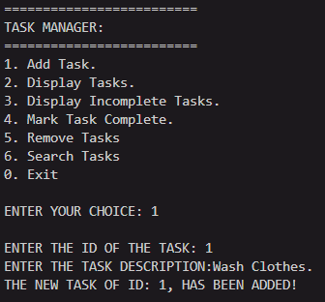

Displaying all tasks:
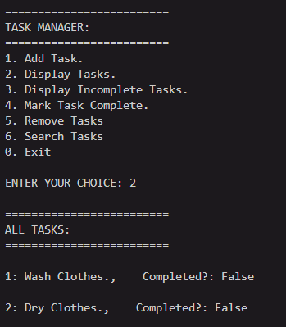
Marking a task as completed: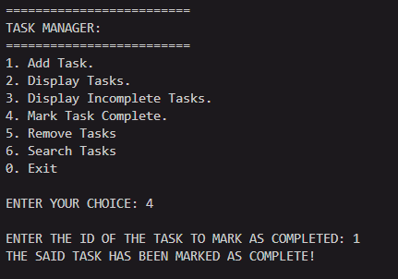

(Verification)
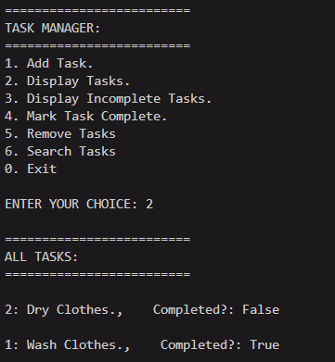

Display only incomplete tasks:
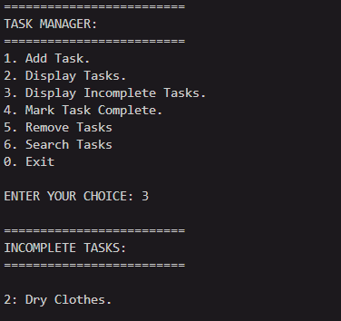

Remove a task:
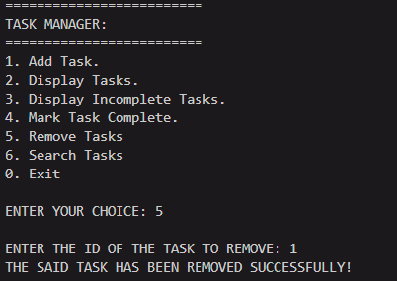

(Verification)
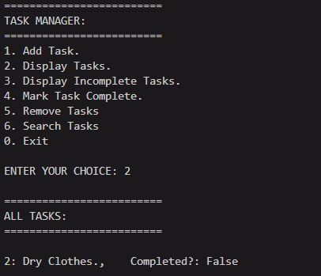

Search for a task:
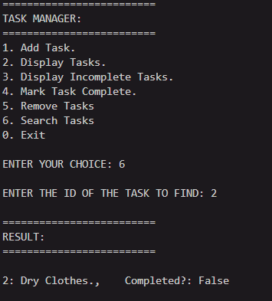

Invalid choices:
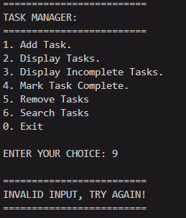

Invalid search ID:
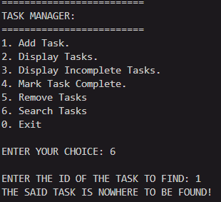
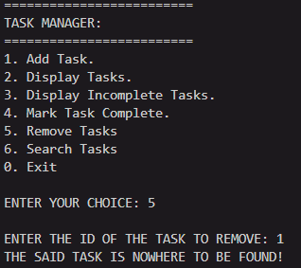

Exit:
